**Lab Session 2 Developing Node.js Web Application and Connect Module**

This document provides the necessary instructions for completing the Week 3 lab session exercises.

**Exercise 1: Develop Node.js Web Application.**

Open VS Code. Open a new folder (File/Open folder…). Name the folder **lab-session-3**.

Open a new Terminal window (Terminal menu, select new).

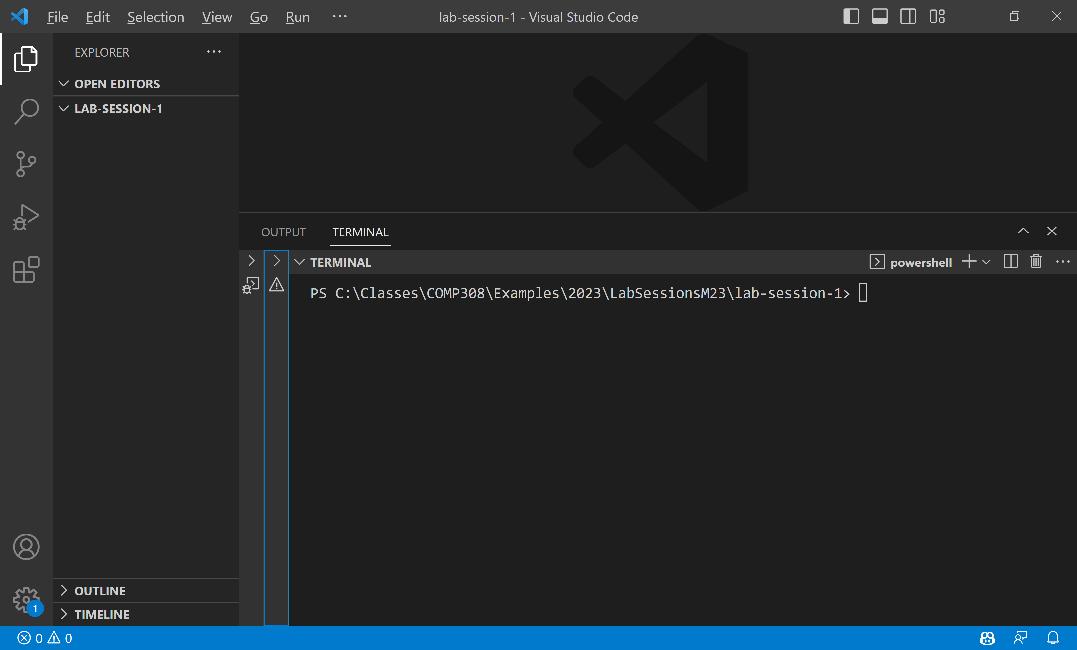

To create the **package.json** file, type **npm init or yarn init** in the terminal window and accept defaults as below:

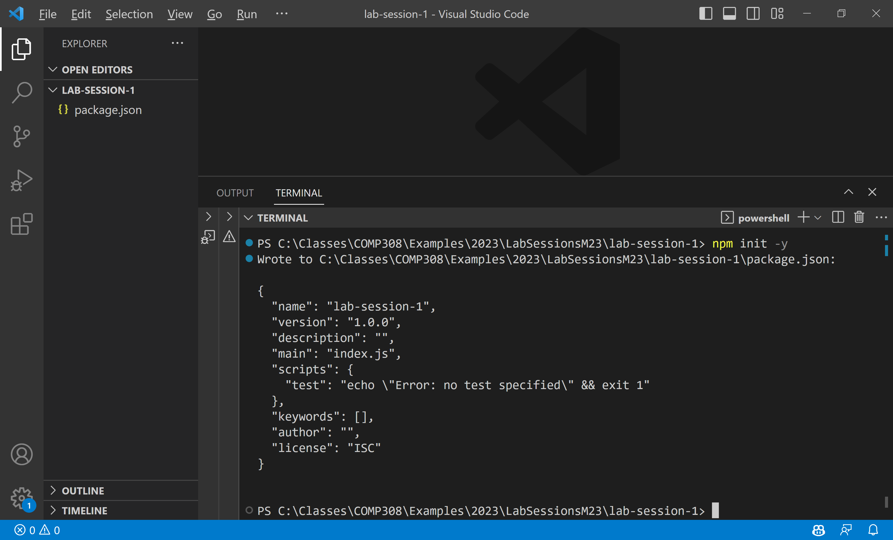

In your working folder, create a file named **server.js** that contains the following code snippet:

**const http = require('http');**

**http.createServer((req, res) => {**

**res.writeHead(200, {**

**'Content-Type': 'text/plain'**

**});**

**res.end('Hello World');**

**}).listen(3000);**

**console.log('Server running at** [**http://localhost:3000/**](http://localhost:3000/)**');**

**run the server.js file as follows:**

**node server**

**Exercise 2: Connect Middleware.**

revise the previous example to include your first middleware. Change your **server.js** file to look like the following code snippet:

**const connect = require('connect');**

**const app = connect();**

**function helloWorld(req, res, next) {**

**res.setHeader('Content-Type', 'text/plain');**

**res.end('Hello World');**

**};**

**app.use(helloWorld);**

**app.listen(3000);**

**console.log('Server running at http://localhost:3000/');**

run the server.js file as follows:

node server

**Exercise 3: Mounting Connect Middleware**

Modify your server.js file to look like the following code snippet:

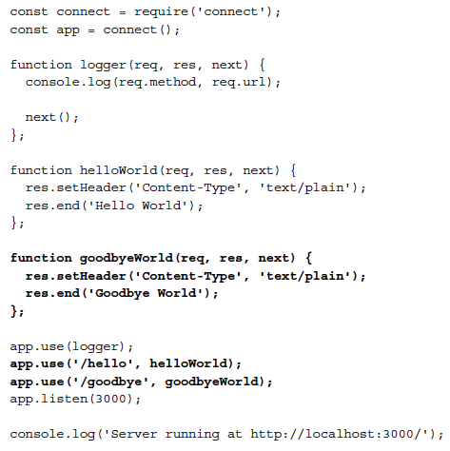

run the server.js file as follows:

node server

Go to the browser and mount the path

Ask for assistance if you encounter any issues during the lab session.

Happy coding!

**References**

Week3 slides

<https://nodejs.org/en/>

<https://code.visualstudio.com/>